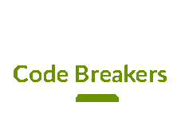

Content

CodeBreakers Project 2

INTRODUCTION 2

ROLES OF TEAM 2

PRESENTATION OF THE PROJECT 2

Realization of the project 2

CODE PLAN 2

Task performance 2

TASK PERFORMANCE 2

# CodeBreakers Project

## INTRODUCTION

Our product is a C++ application, that was made using SDL2 and Physics. You can download the repo and play it.

## ROLES OF TEAM

1. Andrey Mutlu – Scrum Trainer
2. Dimitar Staykov – Designer
3. Ivan Tsrangalov – Front-end Developer
4. Emil Bogdanov – Back-end Developer

## PRESENTATION OF THE PROJECT

* What is the idea of our project?
* How did we realize it?
* What technologies we used?
* How did we communicate?

# Realization of the project

## CODE PLAN

We used Visual Studio Code for the Front- and Back-end work. We included functions and algorithms in the game.

# Task performance

## TASK PERFORMANCE

Roles – everybody had a role and some work to do.

Productivity – we communicated regularly and made important decisions about how the projects was going to be developed.